# CHAPTER 3: SOFTWARE REQUIREMENT SPECIFICATION

## Purpose

## Functional Requirements

### Use Case Diagram

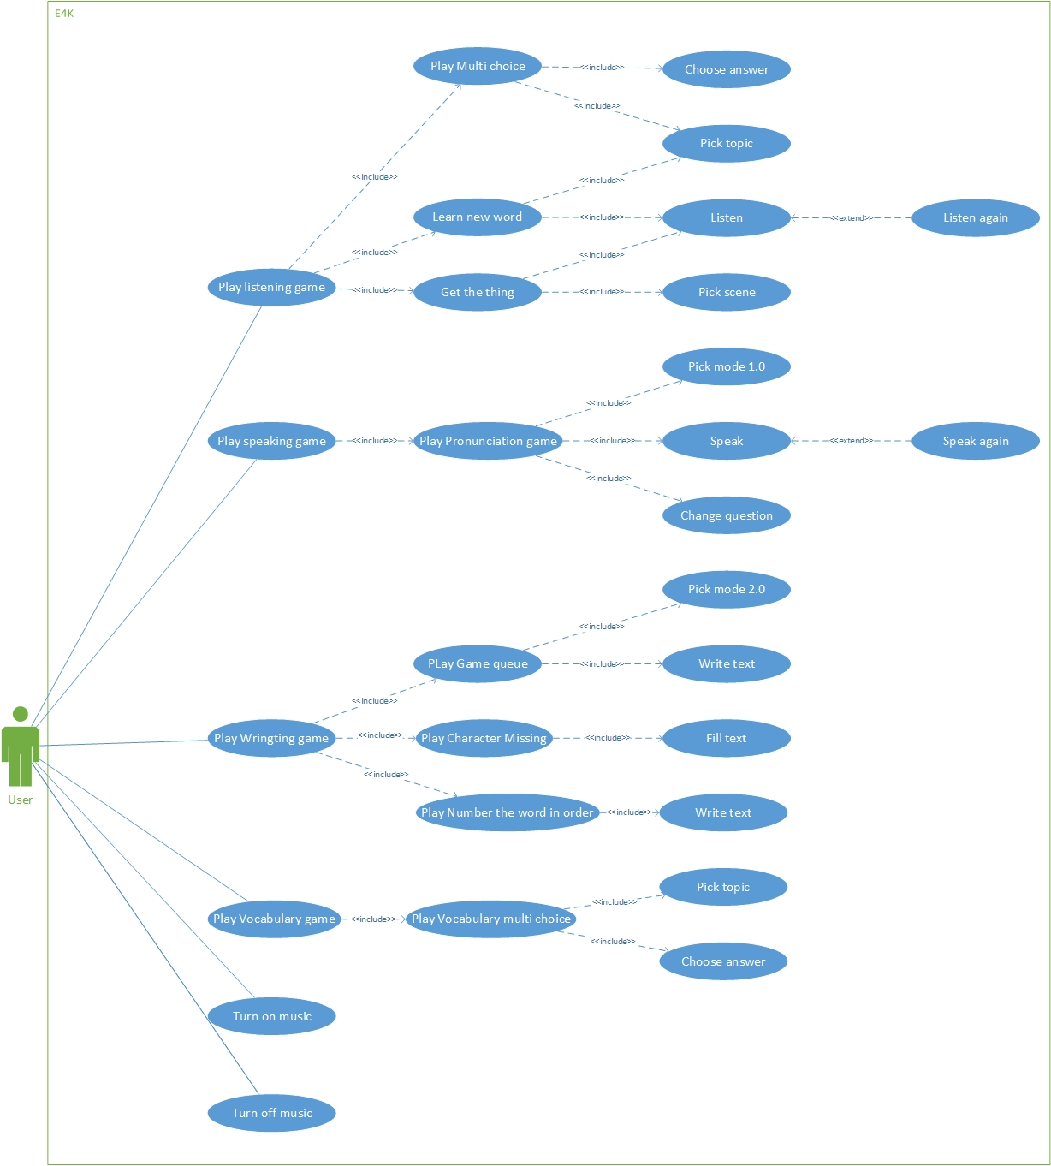

Figure 3‑1 Use case diagram

|  |  |  |
| --- | --- | --- |
| No. | Use-case Name | Summary |
| UC001 | Choose answer | Allows users choose an answer |
| UC002 | Pick topic | Allows users pick a topic |
| UC003 | Listen | Allows users listen new words |
| UC004 | Listen again | Allows users listen new word again |
| UC005 | Pick scene | Allows users pick scene |
| UC006 | Pick mode 1.0 | Allows users pick mode one or two players |
| UC007 | Speak | Allows users speak |
| UC008 | Speak again | Allows users speak again |
| UC009 | Change question | Allows users change question |
| UC010 | Pick mode 2.0 | Allows users pick easy or hard mode |
| UC011 | Fill text | Allows users to fill text missing |
| UC012 | Write text | Allows users write text |
| UC013 | Turn on music | Allows user turn on music |
| UC014 | Turn off music | Allows users turn of music |

### Use Cases

#### Choose answer

|  |  |  |  |
| --- | --- | --- | --- |
| **USE CASE 1 SPECIFICATION** | | | |
| **Use-case No.** | UC001 | **Use-case Version** | 1.0 |
| **Use-case Name** | Choose answer | | |
| **Author** | LongNH | | |
| **Date** | 21/09/2015 | **Priority** | High |
| **Actor**:   * Users.   **Summary**:   * This use case allows users to choose an answer.   **Goal**:   * Choose an answer.   **Triggers:**   * Users tap on one of four options given by the system.   **Preconditions**:   * Four options are shown up successfully.   **Post Conditions:**   * There is one alert sound given by the system. * Redirect to next question screen.   **Main Success Scenario:**   |  |  |  | | --- | --- | --- | | No | Actor | Action | | 1 | Users | Users click on one of four options | | 2 | System | Plays an alert sound | | 3 | System | Shows next question |   **Alternative Scenario:**   * None   **Exceptions:**   * N/A   **Relationships:**   * None   **Business Rules:**   * N/A | | | |

#### Pick topic

|  |  |  |  |
| --- | --- | --- | --- |
| **USE CASE 2 SPECIFICATION** | | | |
| **Use-case No.** | UC002 | **Use-case Version** | 1.0 |
| **Use-case Name** | Pick topic | | |
| **Author** | LongNH | | |
| **Date** | 21/09/2015 | **Priority** | High |
| **Actor**:   * Users.   **Summary**:   * This use case allows users to pick a topic.   **Goal**:   * Pick a topic.   **Triggers:**   * Users tap on one of five topics given by the system.   **Preconditions**:   * Five topics are shown up successfully.   **Post Conditions:**   * Pick a topic successfully. * Redirect to question screen.   **Main Success Scenario:**   |  |  |  | | --- | --- | --- | | No | Actor | Action | | 1 | Users | Users tap on one of five topics given by the system | | 2 | System | Display question screen |   **Alternative Scenario:**   * None   **Exceptions:**   * N/A   **Relationships:**   * None   **Business Rules:**   * N/A | | | |

#### Listen

|  |  |  |  |
| --- | --- | --- | --- |
| **USE CASE 3 SPECIFICATION** | | | |
| **Use-case No.** | UC003 | **Use-case Version** | 1.0 |
| **Use-case Name** | Listen | | |
| **Author** | LongNH | | |
| **Date** | 21/09/2015 | **Priority** | High |
| **Actor**:   * Users.   **Summary**:   * This use case allows users to listen.   **Goal**:   * Plays a sound.   **Triggers:**   * Users tap on the image which includes a sound.   **Preconditions**:   * Users are playing in the listening.   **Post Conditions:**   * Make a sound successfully.   **Main Success Scenario:**   |  |  |  | | --- | --- | --- | | No | Actor | Action | | 1 | Users | Tap on the image which includes a sound. | | 2 | System | Plays the sound. |   **Alternative Scenario:**   * None   **Exceptions:**   * N/A   **Relationships:**   * None   **Business Rules:**   * N/A | | | |

#### Listen again

|  |  |  |  |
| --- | --- | --- | --- |
| **USE CASE 4 SPECIFICATION** | | | |
| **Use-case No.** | UC004 | **Use-case Version** | 1.0 |
| **Use-case Name** | Listen again | | |
| **Author** | LongNH | | |
| **Date** | 21/09/2015 | **Priority** | High |
| **Actor**:   * Users.   **Summary**:   * This use case allows users to listen again.   **Goal**:   * Plays the sound again.   **Triggers:**   * Users tap on the image which includes the sound.   **Preconditions**:   * Users are playing in the listening.   **Post Conditions:**   * Make the sound successfully.   **Main Success Scenario:**   |  |  |  | | --- | --- | --- | | No | Actor | Action | | 1 | Users | Users tap on the image which includes the sound. | | 2 | System | Plays the sound. |   **Alternative Scenario:**   * None   **Exceptions:**   * N/A   **Relationships:**   * None   **Business Rules:**   * N/A | | | |

#### Pick scene

|  |  |  |  |
| --- | --- | --- | --- |
| **USE CASE 1 SPECIFICATION** | | | |
| **Use-case No.** | UC005 | **Use-case Version** | 1.0 |
| **Use-case Name** | Pick scene | | |
| **Author** | LongNH | | |
| **Date** | 21/09/2015 | **Priority** | High |
| **Actor**:   * Users.   **Summary**:   * This use case allows users to pick a scene.   **Goal**:   * Pick a scene.   **Triggers:**   * Users tap on one of four scenes given by the system.   **Preconditions**:   * Four scenes are shown up successfully.   **Post Conditions:**   * Pick a scene successfully. * Redirect to question screen.   **Main Success Scenario:**   |  |  |  | | --- | --- | --- | | No | Actor | Action | | 1 | Users | Users tap on one of four scenes given by the system. | | 2 | System | Display question screen |   **Alternative Scenario:**   * None   **Exceptions:**   * N/A   **Relationships:**   * None   **Business Rules:**   * N/A | | | |

#### Pick mode 1.0

|  |  |  |  |
| --- | --- | --- | --- |
| **USE CASE 1 SPECIFICATION** | | | |
| **Use-case No.** | UC006 | **Use-case Version** | 1.0 |
| **Use-case Name** | Pick mode 1.0 | | |
| **Author** | LongNH | | |
| **Date** | 21/09/2015 | **Priority** | High |
| **Actor**:   * Users.   **Summary**:   * This use case allows users to pick a mode.   **Goal**:   * Pick a mode.   **Triggers:**   * Users tap on one of two modes given by the system.   **Preconditions**:   * Two modes are shown up successfully.   **Post Conditions:**   * Pick a mode successfully. * Redirect to question screen.   **Main Success Scenario:**   |  |  |  | | --- | --- | --- | | No | Actor | Action | | 1 | Users | Users tap on one of two modes given by the system | | 2 | System | Displays question screen |   **Alternative Scenario:**   * None   **Exceptions:**   * N/A   **Relationships:**   * None   **Business Rules:**   * N/A | | | |

#### Speak

|  |  |  |  |
| --- | --- | --- | --- |
| **USE CASE 1 SPECIFICATION** | | | |
| **Use-case No.** | UC007 | **Use-case Version** | 1.0 |
| **Use-case Name** | Speak | | |
| **Author** | LongNH | | |
| **Date** | 21/09/2015 | **Priority** | High |
| **Actor**:   * Users.   **Summary**:   * This use case allows users to speak.   **Goal**:   * Shows user pronunciation in text.   **Triggers:**   * Users click on “Start speaking” button and speak out.   **Preconditions**:   * Users are playing in speaking.   **Post Conditions:**   * Shows user pronunciation in text successfully. * Makes an alert sound for correction or not. * Displays a new word.   **Main Success Scenario:**   |  |  |  | | --- | --- | --- | | No | Actor | Action | | 1 | Users | Users click on "Start speaking" button and speak out | | 2 | System | Displays a text | | 3 | System | Makes an alert sound | | 4 | System | Displays a new word |   **Alternative Scenario:**   * None   **Exceptions:**   * N/A   **Relationships:**   * None   **Business Rules:**   * N/A | | | |

#### Speak again

|  |  |  |  |
| --- | --- | --- | --- |
| **USE CASE 1 SPECIFICATION** | | | |
| **Use-case No.** | UC008 | **Use-case Version** | 1.0 |
| **Use-case Name** | Speak again | | |
| **Author** | LongNH | | |
| **Date** | 21/09/2015 | **Priority** | High |
| **Actor**:   * Users.   **Summary**:   * This use case allows users to speak again.   **Goal**:   * Shows user pronunciation in text again.   **Triggers:**   * Users click on “Speak again” button and speak out.   **Preconditions**:   * Users are playing in speaking   **Post Conditions:**   * Shows user pronunciation in text successfully. * Makes an alert sound for correction or not. * Displays a new word.   **Main Success Scenario:**   |  |  |  | | --- | --- | --- | | No | Actor | Action | | 1 | Users | Users click on "Speak again" button | | 2 | System | Displays user pronunciation in text | | 3 | System | Makes an alert sound | | 4 | System | Displays a new word |   **Alternative Scenario:**   * None   **Exceptions:**   * N/A   **Relationships:**   * None   **Business Rules:**   * N/A | | | |

#### Change question

|  |  |  |  |
| --- | --- | --- | --- |
| **USE CASE 1 SPECIFICATION** | | | |
| **Use-case No.** | UC009 | **Use-case Version** | 1.0 |
| **Use-case Name** | Change question | | |
| **Author** | LongNH | | |
| **Date** | 21/09/2015 | **Priority** | High |
| **Actor**:   * Users.   **Summary**:   * This use case allows users to change the current question.   **Goal**:   * Change the current question.   **Triggers:**   * Users click on “Change question” button   **Preconditions**:   * Users are playing in speaking. * There is a question already shown to users.   **Post Conditions:**   * Makes a new question successfully.   **Main Success Scenario:**   |  |  |  | | --- | --- | --- | | No | Actor | Action | | 1 | Users | Users click on “Change question” button | | 2 | System | Displays a new question |   **Alternative Scenario:**   * None   **Exceptions:**   * N/A   **Relationships:**   * None   **Business Rules:**   * N/A | | | |

#### Pick mode 2.0

|  |  |  |  |
| --- | --- | --- | --- |
| **USE CASE 1 SPECIFICATION** | | | |
| **Use-case No.** | UC010 | **Use-case Version** | 1.0 |
| **Use-case Name** | Pick mode 2.0 | | |
| **Author** | TuanDV | | |
| **Date** | 21/09/2015 | **Priority** | High |
| **Actor**:   * Users.   **Summary**:   * This use case allows users pick easy or hard mode.   **Goal**:   * Pick a mode.   **Triggers:**   * Users tap on one of two modes given by the system.   **Preconditions**:   * Two modes are shown up successfully.   **Post Conditions:**   * Pick a mode successfully. * Redirect to question screen.   **Main Success Scenario:**   |  |  |  | | --- | --- | --- | | No | Actor | Action | | 1 | Users | Users tap on one of two modes given by the system | | 2 | System | Displays question screen |   **Alternative Scenario:**   * None   **Exceptions:**   * N/A   **Relationships:**   * None   **Business Rules:**   * N/A | | | |

#### Fill text

|  |  |  |  |
| --- | --- | --- | --- |
| **USE CASE 3 SPECIFICATION** | | | |
| **Use-case No.** | UC011 | **Use-case Version** | 1.0 |
| **Use-case Name** | Fill text | | |
| **Author** | TuanDV | | |
| **Date** | 21/09/2015 | **Priority** | High |
| **Actor**:   * User.   **Summary**:   * This use case allows user to fill text missing.   **Goal**:   * Fill text missing   **Triggers:**   * User tap on where text missing and typing from keybroad   **Preconditions**:   * Question are shown up successfully.   **Post Conditions:**   * User filled character missing   **Main Success Scenario:**   |  |  |  | | --- | --- | --- | | No | Actor | Action | | 1 | User | User tap on where character missing | | 2 | User | User type character from keybroad | | 3 | System | Fill character into where user typed |   **Alternative Scenario:**   * None   **Exceptions:**   * N/A   **Relationships:**   * None   **Business Rules:**   * N/A | | | |

#### Write text

|  |  |  |  |
| --- | --- | --- | --- |
| **USE CASE 3 SPECIFICATION** | | | |
| **Use-case No.** | UC012 | **Use-case Version** | 1.0 |
| **Use-case Name** | Write text | | |
| **Author** | TuanDV | | |
| **Date** | 21/09/2015 | **Priority** | High |
| **Actor**:   * User.   **Summary**:   * This use case allows user to write text   **Goal**:   * Write text   **Triggers:**   * User tap on where text answer and typing from keybroad   **Preconditions**:   * Question are shown up successfully.   **Post Conditions:**   * User filled character in answer   **Main Success Scenario:**   |  |  |  | | --- | --- | --- | | No | Actor | Action | | 1 | User | User tap on answer text | | 2 | User | User type character from keybroad | | 3 | System | Show character into where user typed |   **Alternative Scenario:**   * None   **Exceptions:**   * N/A   **Relationships:**   * None   **Business Rules:**   * N/A | | | |

#### Turn on music

|  |  |  |  |
| --- | --- | --- | --- |
| **USE CASE 3 SPECIFICATION** | | | |
| **Use-case No.** | UC013 | **Use-case Version** | 1.0 |
| **Use-case Name** | Turn on music | | |
| **Author** | TuanDV | | |
| **Date** | 21/09/2015 | **Priority** | High |
| **Actor**:   * Users.   **Summary**:   * This use case allows users turn on music   **Goal**:   * Music is able.   **Triggers:**   * Users tap on the sound icon.   **Preconditions**:   * Sound is off   **Post Conditions:**   * Sound is turned on   **Main Success Scenario:**   |  |  |  | | --- | --- | --- | | No | Actor | Action | | 1 | Users | Tap on sound icon | | 2 | System | Plays the sound |   **Alternative Scenario:**   * None   **Exceptions:**   * N/A   **Relationships:**   * None   **Business Rules:**   * N/A | | | |

#### Turn off music

|  |  |  |  |
| --- | --- | --- | --- |
| **USE CASE 3 SPECIFICATION** | | | |
| **Use-case No.** | UC013 | **Use-case Version** | 1.0 |
| **Use-case Name** | Turn off music | | |
| **Author** | TuanDV | | |
| **Date** | 21/09/2015 | **Priority** | High |
| **Actor**:   * Users.   **Summary**:   * This use case allows users turn off music   **Goal**:   * Music is disable.   **Triggers:**   * Users tap on the sound icon.   **Preconditions**:   * Sound is on   **Post Conditions:**   * Sound is turned off   **Main Success Scenario:**   |  |  |  | | --- | --- | --- | | No | Actor | Action | | 1 | Users | Tap on sound icon | | 2 | System | Music is disable |   **Alternative Scenario:**   * None   **Exceptions:**   * N/A   **Relationships:**   * None   **Business Rules:**   * N/A | | | |